**Output:**

# **Name : Rajkumar B L**

# **Reg.No : 2047120**

# **Course : MCS 272 Mobile Application**

# **(Lab 05 – Fotato Eats)**

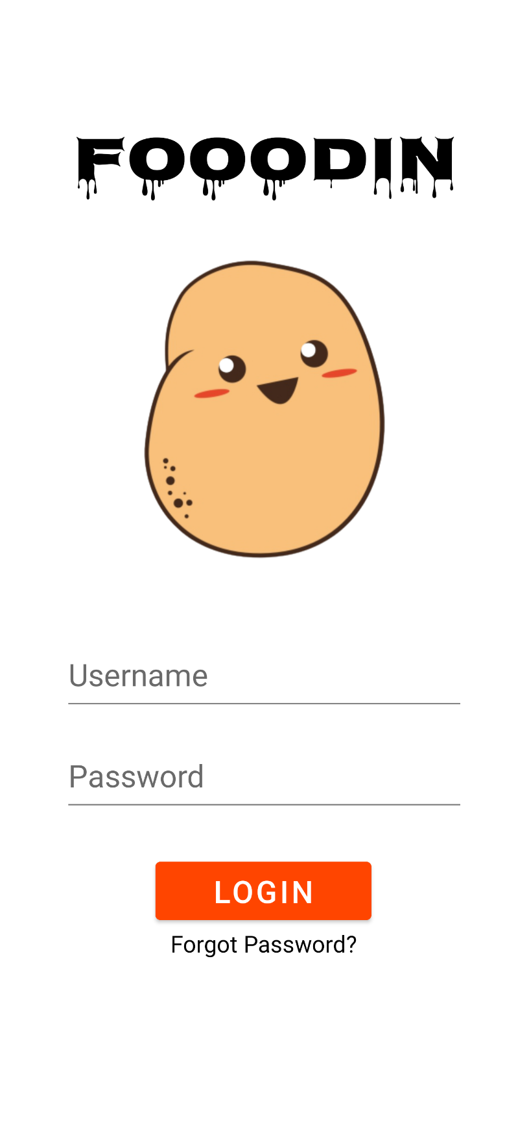1. Splash Screen 2. Welcome Screen



3. Login Page (TextView,EditText) 4. Food Type (Button, Float)

5. South Menu (Image Button) 6. Item(WebView, CheckBox)

7. Input (Spinner) 8. Input (Rating Bar)

9. Cart before adding items 10. Idli added to cart (Snack Bar)

11. Cart after adding idli 12. Puttu added to cart (Snack Bar)

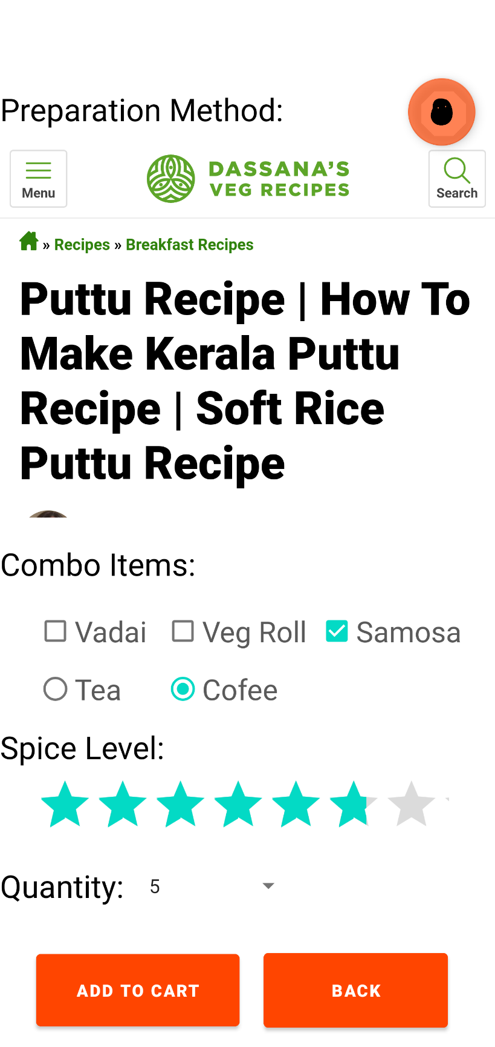

13. Cart after adding puttu 14. App Icon



**The code used in the Main Activity, XML layout, Splash scree, button ripple effect is attached below for reference.**